Conversational KYC Assistant with Agentic Workflow

Submitted in the partial fulfillment of the requirements
for the degree of B.Tech in Computer Engineering

by

Swarnima Negi (DY22ENGUOCOM166 − 22CE1117)

Supervisor
Dr. Vishakha K. Gaikwad

Department of Computer Engineering
Ramrao Adik Institute of Technology
Sector 7, Nerul, Navi Mumbai
(Under the ambit of D. Y. Patil Deemed to be University)
May 2026

Ramrao Adik Institute of Technology
(Under the ambit of D. Y. Patil Deemed to be University)
Dr. D. Y. Patil Vidyanagar, Sector 7, Nerul, Navi Mumbai 400 706

CERTIFICATE

This is to certify that, the Internship report entitled

Conversational KYC Assistant with Agentic Workflow
is a bonafide work done by
Swarnima Negi (DY22ENGUOCOM166 − 22CE1117)

and is submitted in the partial fulfillment of the requirement for the degree of

B.Tech in Computer Engineering
to the
D. Y. Patil Deemed to be University

Mentor | Supervisor | Internship Co-ordinator
Name of Company Mentor | (Dr. Vishakha K. Gaikwad) | Name of Internship Co-ordinator

Head of Department | Principal
(Dr. Amarsinh V. Vidhate) | (Dr. Mukesh D. Patil)

Internship Report Approval

This is to certify that the Internship entitled “Conversational KYC Assistant with Agentic Workflow” is a bonafide work done by Swarnima Negi (DY22ENGUOCOM166 − 22CE1117) under the supervision of Dr. Vishakha K. Gaikwad. This internship is approved in the partial fulfillment of the requirement for the degree of B.Tech in Computer Engineering.

Internal Examiner :
1. . . . . . . . . . . . . . . . . . . . . . . . . . . . . . .
2. . . . . . . . . . . . . . . . . . . . . . . . . . . . . . .

External Examiners :
1. . . . . . . . . . . . . . . . . . . . . . . . . . . . . . .
2. . . . . . . . . . . . . . . . . . . . . . . . . . . . . . .

Date : . . . /. . . /. . . . . .
Place : . . . . . . . . . . . .

DECLARATION

I declare that this written submission represents my ideas and does not involve plagiarism. I have adequately cited and referenced the original sources wherever others’ ideas or words have been included. I also declare that I have adhered to all principles of academic honesty and integrity and have not misrepresented or fabricated or falsified any idea, data, fact, or source in my submission. I understand that any violation of the above will be cause for disciplinary action against me by the Institute and can also evoke penal action from the sources which have thus not been properly cited or from whom proper permission has not been taken when needed.

Date:

Swarnima Negi (DY22ENGUOCOM166 − 22CE1117)

Abstract
Every financial institution in India has to run a Know Your Customer (KYC) check before it can start working with a customer, and the way this check is done has changed a lot over the years. For a long time, KYC meant a trip to the bank with a folder of photocopies. Digital KYC and Video KYC have made a real difference since then. The problem is that the user is still mostly left to figure things out on their own, which is hard when someone is not used to digital platforms in the first place. This shows up clearly in rural and semi-urban parts of India, where people often give up halfway through the process.
The project in this report tries to help here. It is a Conversational KYC Assistant that chats with the user in Hindi or English and walks them through each step of the KYC flow. Under the hood, the assistant uses a vision based model to read identity documents like Aadhaar and PAN, and the DeepFace library to match a live selfie with the photograph on the document (Serengil & Ozpinar, 2020). Approval, re-upload, and flag-for-review decisions are handled by a LangGraph based agentic workflow, and a Retrieval Augmented Generation (RAG) pipeline (Lewis et al., 2020) is used during the conversation so the assistant can answer KYC questions without making things up.
A few pieces are still in progress. An admin module for case review is being built out so that flagged cases can be worked through by a human reviewer. Face liveness detection using MediaPipe Face Mesh is also in the works (Lugaresi et al., 2019), which should make it harder for someone to game the system with a printed photo or a short video clip. Gender and age estimation will be layered on top as one more cross check against the document. And for users who would rather listen than read, TTS support is being wired in.
On the technology side, the frontend is written in React. The backend runs on Python with FastAPI, and all the data sits in a PostgreSQL database. This report walks through what went into the current Proof of Concept (POC) during the internship, where the system stands today, and what the next phase of work will look like.

Contents

List of Tables

List of Figures
3.1 System Architecture of the Conversational KYC Assistant 10
4.1 KYC Verification Workflow 14
C.1 Attendance Report 18
D.1 Internship Completion Certificate 19

Chapter 1: Introduction
Anyone opening a bank account in India today has to go through something called KYC, which is short for Know Your Customer. The idea is straightforward. Before a bank, an insurance company, a mutual fund house, or even a telecom operator hands you whatever product you are asking for, they have to be reasonably sure you are who you say you are. The Reserve Bank of India lays down these rules under the Prevention of Money Laundering Act of 2002 (Reserve Bank of India, 2016). The bigger picture reason is to keep fraud, money laundering, and terrorist financing out of the formal financial system. But for a normal customer, KYC is basically the paperwork that stands between them and their new account.
In its original form, KYC was entirely paper based. A customer would walk into a branch with a photocopy of their Aadhaar, PAN card, passport, a utility bill, and a passport photo. A bank officer would sit with these documents, compare them against the originals, type the details into the system, and file everything away. It worked, but it was slow. A file could take a week or two to clear, one typo meant rechecking the whole form, and the cost of storing physical records kept piling up.
eKYC and Video KYC changed a lot of this. Users could finally complete their KYC from home, without setting foot in a branch. But something else shifted in the process. The effort moved from the bank officer to the user, and the user now had to navigate a series of screens, upload documents in a specific way, and get their face aligned with a camera, all without anyone guiding them through it. When the interface is not self explanatory, or when an upload fails silently, people simply give up.
Step outside the metro cities and the problem gets sharper. Not everyone in India is comfortable with a smartphone app, and on top of that, most KYC screens are written in English. For someone who thinks in Hindi or a regional language, that is one more wall to get past. The irony is hard to miss. There are perfectly eligible customers who cannot finish a KYC process, and it has nothing to do with whether they meet the actual rules. It has everything to do with whether they can follow the app that is supposed to help them.

1.1 Overview
This gap is the starting point for the project. The idea was to build a Conversational KYC Assistant that acts a bit like a helpful bank officer sitting across a desk, guiding the user through each step of the process and explaining what is needed at every stage.
Instead of a form with a dozen fields, the user has a conversation. The assistant asks for one thing at a time. The backend does the heavy lifting quietly, reading the document, pulling out fields like name and date of birth, capturing a selfie, comparing it with the document photograph, and the user just has to respond naturally.
The work is structured as an agentic workflow so the assistant can adapt to what actually happens at each step. If the uploaded document is too blurry to read, it simply asks for another picture. If the face match does not pass, it requests a new selfie. If everything looks clean, the case moves forward. The point is that the user never has to guess what comes next.
At the time of this report, the focus has been on getting the core KYC flow working end to end: document collection, field extraction, face verification, and decision making. Alongside this, a few other pieces are being built and will be integrated once they are stable. These include an admin module, face liveness detection, gender and age estimation, and TTS support.

1.2 Roles and Responsibilities
My internship work was spread across the Conversational KYC Assistant end to end, with support from my company mentor and the rest of the product team. The main things I worked on are listed below.
- Requirement Analysis: Looking at the KYC process in detail and mapping out where today's digital KYC systems tend to slip, particularly when it comes to user guidance and interface clarity.
- Frontend Development: The entire user facing side was built in React with shadcn/ui. This covered the chat screen, the document upload view with preview, and the camera view where users capture a selfie.
- Backend Development: The backend was written in Python with FastAPI. This was where the REST endpoints lived, along with all the file handling and the plumbing that tied the different AI services together.
- Agentic Workflow Design: Putting the KYC flow together as an agentic graph in LangGraph. Each verification step became a node in the graph, and the path from one node to the next was driven by what the previous node returned.
- Document Processing Integration: A vision based model was plugged in to read Aadhaar and PAN images. It returns the fields that actually matter downstream, such as the name, date of birth, document number, and address.
- Face Verification Module: Built around DeepFace. Given a selfie from the camera view and the photograph from the uploaded document, it produces a similarity score that the rest of the decision logic can act on.
- Workflow and Decision Logic: This was essentially the glue around the AI modules. The logic decides whether a case can be approved, whether the user needs to re-upload a specific document, or whether a case should be set aside for a human reviewer.
- Testing and Debugging: A fair bit of this. Unit tests on the individual modules, integration tests across the end to end flow, and a steadily growing list of deliberately messy edge cases that came out of real testing.
- Research and Exploration: Reading up on the pieces planned for the next phase. That meant MediaPipe based liveness detection, gender and age estimation, TTS for audio responses, and the admin module for case review.

1.3 Organization of the report
Here is how the rest of the report is laid out.
- Chapter 2 takes a look at existing KYC systems and where the common pain points sit.
- Chapter 3 walks through the proposed system, its methodology, and the overall architecture.
- Chapter 4 covers the implementation, testing, and the results from the internship.
- Chapter 5 wraps up with a summary of the work, the deliverables, and the recommendations for future work.

Chapter 2: Analysis of Existing Solutions
KYC systems in use today can be broadly grouped into two categories. The first is the traditional paper based process that predates the shift to digital platforms, and the second is the modern digital category, which covers eKYC and Video KYC. Both categories are still in active use, and each one brings its own set of operational and usability challenges. These challenges directly informed several of the design choices made in this project.
The paper based process has been the standard approach for decades. A customer visits the branch, submits photocopies of the required identity and address proofs, and a staff member verifies these documents against the originals. The process is reliable, but it is also slow, manual, and resource intensive. A single data entry error often requires the entire form to be rechecked, and the cost of maintaining physical records grows along with the customer base. This makes the approach difficult to scale across millions of users.
Digital KYC was introduced to address most of these limitations, and it has been largely successful on that front. Users can now complete the verification process remotely, within a few minutes, from a mobile device. The interface design, however, has not kept pace with this shift. The flow is still structured around a sequence of forms and screens, and the user is expected to understand the requirements of each step without real time support. Abandonment rates in such flows remain a significant concern for financial institutions, particularly among first time users.
From a technical standpoint, most digital KYC systems are built around three core capabilities. The first is document reading through Optical Character Recognition (OCR). The second is face recognition, which compares the user’s selfie with the photograph on the submitted document. The third is a basic liveness check, typically based on user actions such as blinking or smiling. Each of these has its own limitations. Traditional OCR performs well on clean, machine printed text, but accuracy drops on Indian identity documents, which often contain stamps, logos, coloured backgrounds, and text in multiple languages. More recent vision language models address this gap, although their adoption in production KYC systems is still limited. Face recognition libraries such as DeepFace deliver strong results on clear, well lit frontal images, though performance degrades in poor lighting conditions or when the user is not directly facing the camera (Serengil & Ozpinar, 2020).
The liveness component presents a more serious limitation. Blink or smile based checks can often be bypassed using a printed photograph or a short pre-recorded video, which reduces the security value they provide. In addition, most existing systems are available only in English and do not offer any form of real time conversational guidance, which places the full burden of interpretation on the user. This is particularly problematic for users who are not already familiar with digital platforms.
Taken together, the gaps in existing KYC systems can be summarised along two axes. On one side, the verification is technically robust but the interface is difficult to navigate. On the other, the interface may be simpler but the underlying verification is not strong enough. A system that combines vision based document reading, reliable face verification, a structured agentic workflow, and a conversational interface in the user’s own language has the potential to close both gaps within a single design.

Chapter 3: Proposed System

3.1 Problem Statement
Whether you look at the paper based KYC process or the digital one, there is one thing missing from both: an interface that actively helps the user through the flow. The paper version leans entirely on physical visits and manual checks. The digital version throws a multi step form at the user and expects them to work it out. For anyone who is not used to digital platforms, this can easily mean a dropped application halfway through.
Beyond the usability gap, most existing systems also treat document processing, face verification, and decision making as separate pieces that only loosely work together. Regional language support is rare, and real time conversational guidance is rarer still. This project addresses both sides of the gap by combining a guided, chat based interface with an agentic workflow that stitches all the verification steps into a single, coherent flow.

3.2 Project Methodology/Techniques
The design is built around a single agentic workflow, with LangGraph orchestrating the whole thing. The user talks to the agent through a chat interface, and the agent picks the next step based on what the previous step returned. The overall flow is broken into five phases, which together form a semi automated KYC pipeline.

Phase 1: Conversational Interaction
The first phase is just the conversation itself. A chat screen built in React with shadcn/ui sits between the user and everything that happens afterwards. The assistant opens with a greeting, tells the user what KYC is going to ask of them in simple language, and then takes them one step at a time. It can speak both Hindi and English right out of the gate, and TTS is on its way in for users who would rather listen than read.

Phase 2: Document Collection and Processing
Once the user is ready, they upload an identity document. In most cases this is an Aadhaar or a PAN card. The image makes its way to a vision based model on the backend, which reads the whole thing and comes back with structured fields: the name, date of birth, document number, and address. We went with a vision model over classical OCR on purpose. Stamps, logos, and multilingual text are enough to throw OCR off on the kind of ID documents people actually carry in India, and the vision model reads the layout as a whole so it deals with these cases a lot more gracefully.

Phase 3: Face Verification and Liveness Check
With the document processed, the assistant moves on to the selfie. The selfie and the photograph from the document go through DeepFace, which hands back a similarity score (Serengil & Ozpinar, 2020). A liveness check using MediaPipe Face Mesh is being layered in so that a printed photo or a video replay cannot slip past the system (Lugaresi et al., 2019). Gender and age estimation will be used as a rough secondary check, where the estimated age from the selfie is compared against the date of birth pulled off the document.

Phase 4: Cross Validation and Compliance Checking
Once the face check passes, the extracted fields from all submitted documents are cross validated. The simplest example: the name and date of birth on the Aadhaar should match the ones on the PAN. A RAG pipeline sits alongside this step and is used to answer KYC related questions from the user, grounded on a small set of reference compliance documents (Lewis et al., 2020).

Phase 5: Decision Making
The last phase is where the agent pulls everything together and takes a call. The case is either approved, sent back for a specific document re-upload, or flagged for a human reviewer. Because this decision lives inside the LangGraph workflow, the exact path each case took is easy to reconstruct later.

3.3 Design and Architecture

System Overview
The system follows a layered architecture with five distinct layers: the frontend, the API layer, the agent orchestration layer, the processing services layer, and the data layer. Each layer has a clear job, and the interfaces between them are intentionally narrow. Figure 3.1 shows how these layers fit together.
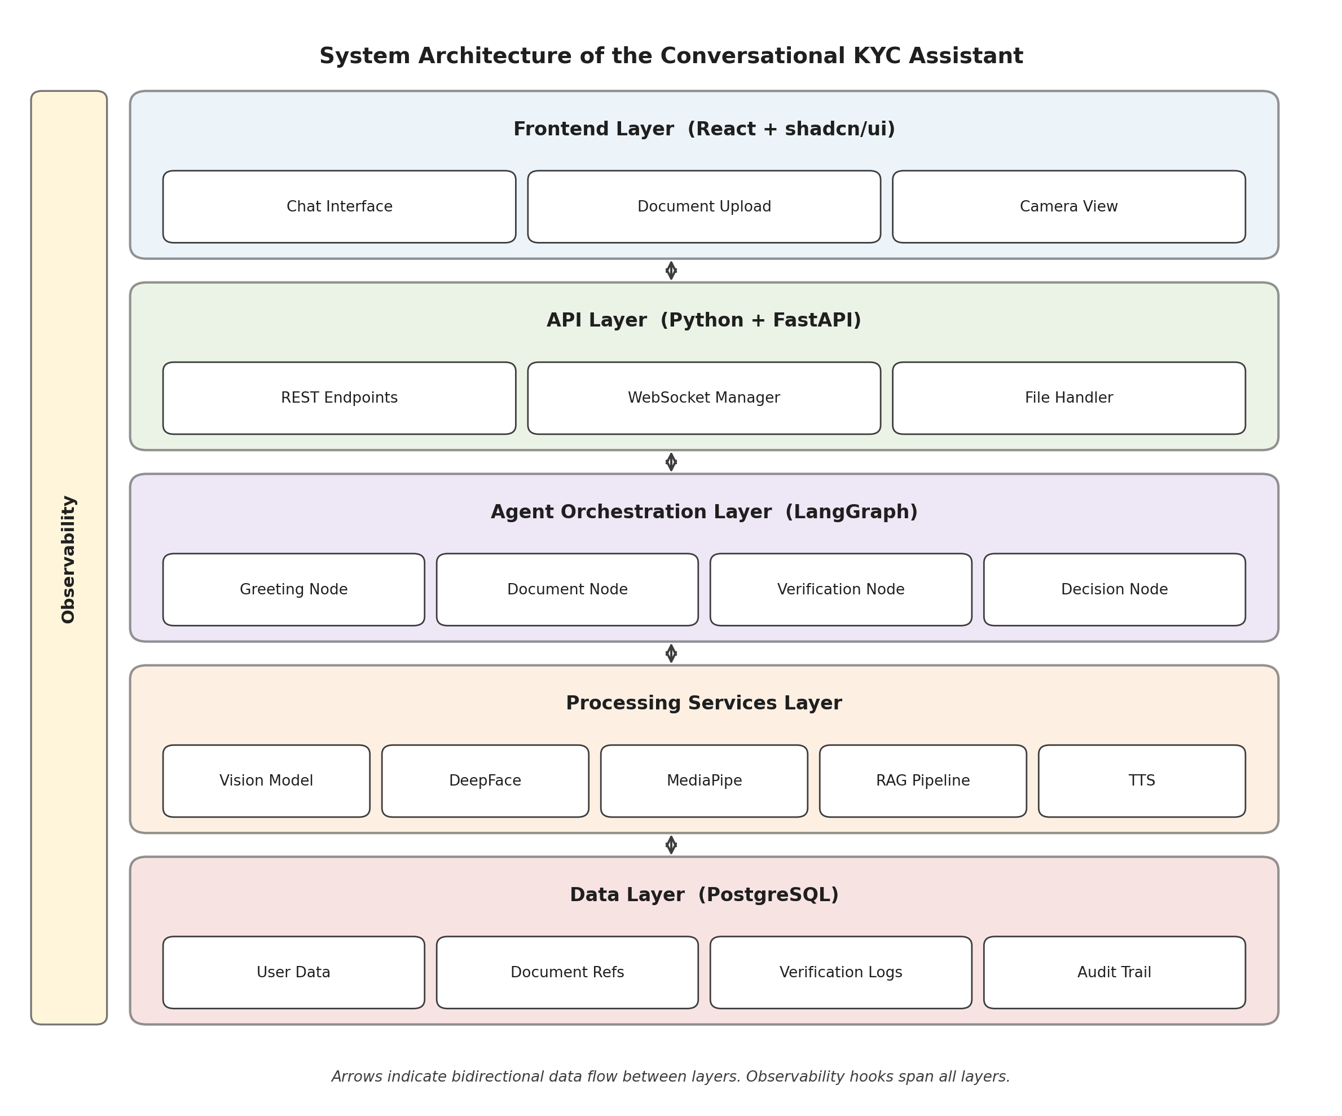
Figure 3.1: System Architecture of the Conversational KYC Assistant

Frontend Layer
The frontend is a single page application. It carries the chat interface, the document upload screen with image preview, and the camera view for capturing a selfie. A progress indicator keeps the user in the loop about where they are in the KYC flow. REST APIs handle the standard request and response traffic, and WebSockets are used where real time updates matter during the conversation.

API Layer (Backend)
The backend is written in Python and built on FastAPI (Ramírez, 2018). It takes in requests from the frontend, manages the file uploads, routes data to the right AI service, and ships the response back. FastAPI was picked over Flask because of its async request handling, automatic request validation through Python type hints, and the built in OpenAPI docs, all of which matter in an API first system.

Agent Orchestration Layer
This layer is the brain of the system and sits on top of LangGraph. Each stage of the KYC flow, greeting, document collection, document processing, face verification, cross validation, and decision making, is modeled as a node in the graph. Transitions between nodes are driven by what each node returns, which keeps the overall flow structured and easy to trace.

Processing Services Layer
The processing services layer holds the actual AI components. The vision based document processing service reads the uploaded documents and returns structured fields. The face verification service uses DeepFace to compare the selfie with the document photograph. The liveness, gender and age estimation, and TTS services will join this layer in the next phase. A RAG pipeline also sits here, and is used to answer KYC related questions during the conversation.

Data Layer
The data layer is a PostgreSQL database. It stores user information, references to uploaded documents, extracted fields, and verification results. System logs also go into the same layer so any given case can be audited afterwards.

Observability
A thin observability layer cuts across the whole system. Basic hooks around requests, model responses, and decision outcomes make it much easier to figure out where a case slowed down or went sideways, which has already been useful during testing.

3.4 Skills Development
This internship gave me a chance to work on a full stack AI application from scratch, and the learning was spread across a few areas.
On the frontend side, I got much more comfortable with React and component driven design, and with shadcn/ui in particular as a way to build clean interfaces quickly. On the backend, most of my time went into Python and FastAPI, which tightened up my skills around designing REST APIs, handling file uploads, dealing with async requests, and writing code that is easy to test.
The AI side was probably the most interesting part for me. I worked hands on with vision based document processing, face verification using DeepFace, and agentic workflows built on LangGraph. The RAG pipeline in particular was something I had only read about before, and getting to use it in a real application made the idea of retrieval plus generation a lot clearer than any tutorial could.
Outside the code, I also picked up a lot on how to work on a real project with a team. Breaking the work into modules, planning the order things needed to be done in, discussing design trade offs with my mentor, and writing documentation that other people could actually use, were all parts of the internship that I expect to carry into future projects.

Chapter 4: Results and Discussion
This chapter walks through what came out of the development and testing phases of the Conversational KYC Assistant. It covers how the different modules were built and integrated, how they were tested, and how the results line up against the existing KYC solutions discussed earlier in the report.

4.1 Implementation Details
The Conversational KYC Assistant was put together as a full stack application, with clear lines between the user interface, the backend services, and the AI components. This separation made it easier to develop, test, and tweak each part on its own over the course of the internship.
The frontend was built in React with shadcn/ui. It gives the user a chat style interface for the whole KYC flow, along with a document upload screen that shows an image preview, a camera view for capturing a live selfie, and a progress indicator so the user can see how much of the flow is left. The design tries to stay as uncluttered as possible so that users who are new to digital platforms are not overwhelmed.
The backend was written in Python using FastAPI. Python was a natural fit because almost all of the AI libraries for this project are Python first, which keeps the integration simple. FastAPI was chosen over Flask for a handful of practical reasons: async request handling, automatic request validation through type hints, and the built in OpenAPI documentation, which made it easy to share endpoint specs with the rest of the team. The backend handles incoming requests from the frontend, manages file uploads, invokes the right AI service for each request, and talks to the database.
For document processing, a vision based approach was used instead of traditional OCR. The assistant accepts Aadhaar and PAN card images and pulls out structured fields including name, date of birth, document number, and address. This choice was deliberate. Real world Indian identity documents come with stamps, logos, colored backgrounds, and text in more than one language, and classical OCR tends to misread these in ways that are hard to recover from downstream. The vision based model handles these cases a lot more gracefully.
Face verification was built on top of the DeepFace library in Python. When the user captures a selfie through the camera view, the backend compares it against the photograph extracted from the uploaded document and returns a similarity score. This score then feeds into the validation logic, which also does cross field checks across documents to flag things like a name that does not match between the Aadhaar and the PAN.
LangGraph orchestrates the whole flow. Every stage of the KYC process, document upload, field extraction, face verification, cross validation, and decision making, is modeled as a node in the agent graph. Based on what each node returns, the graph can move forward, ask for a re-upload, or flag the case for a reviewer. A RAG pipeline is layered into the conversation for grounded responses on compliance questions, and a PostgreSQL database holds user data, document references, and verification outcomes.

4.2 Testing Strategies
Testing was approached at a few different levels. The plan was to cover both the happy path and the messier edge cases that show up in any real KYC deployment.
Unit testing came first. Each module was put through its paces on its own. The document extraction module was run against a small pool of sample Aadhaar and PAN images to confirm that the expected fields were coming out cleanly. The face verification module was tested with pairs of matching and mismatched faces to make sure the similarity scores behaved sensibly in both directions. The validation logic was given a mix of clean inputs and deliberately broken ones, like a name that does not match across documents, to confirm that the right decision came out at the other end.
Integration testing came next. This layer focused on how the pieces hang together through the FastAPI backend. A typical integration run started at the frontend: the user uploads a document, the backend triggers the vision model, the extracted data goes through validation, a selfie is captured, face verification runs, and a decision finally comes back to the user. Running this end to end caught several issues that the unit tests could not, such as response format mismatches and small bugs in how data was handed off between modules.
Edge cases also got a fair amount of attention. Blurred document images, poor lighting during selfie capture, partially visible faces, and documents with unclear fields were all part of the test set. Beyond just confirming that the system did not crash, these tests drove a real improvement in the user facing error messages, which now nudge the user toward retaking the photo or re-uploading the document instead of leaving them staring at a generic error.
Some informal performance observations were made as well. Response times for document processing and face verification were tracked during the test runs to make sure the flow stayed quick enough for an interactive chat experience.

4.3 Result Analysis
The system is now able to run through the core KYC flow end to end: guided conversation, document upload, field extraction, face verification, and decision making. The chat based interface turned out to be one of the design choices that paid off the most. Instead of asking the user to fill out a form with a dozen fields and buttons, the assistant asks for one thing at a time and explains what comes next, which ends up feeling a lot closer to the way a real bank officer would walk someone through KYC in person.
Figure 4.1 shows the end to end flow as it actually runs. Each decision point in the diagram corresponds to a node in the LangGraph agent, which is what lets the system retry a step, push the case forward, or route it to a human reviewer without any of this logic being scattered across the code.
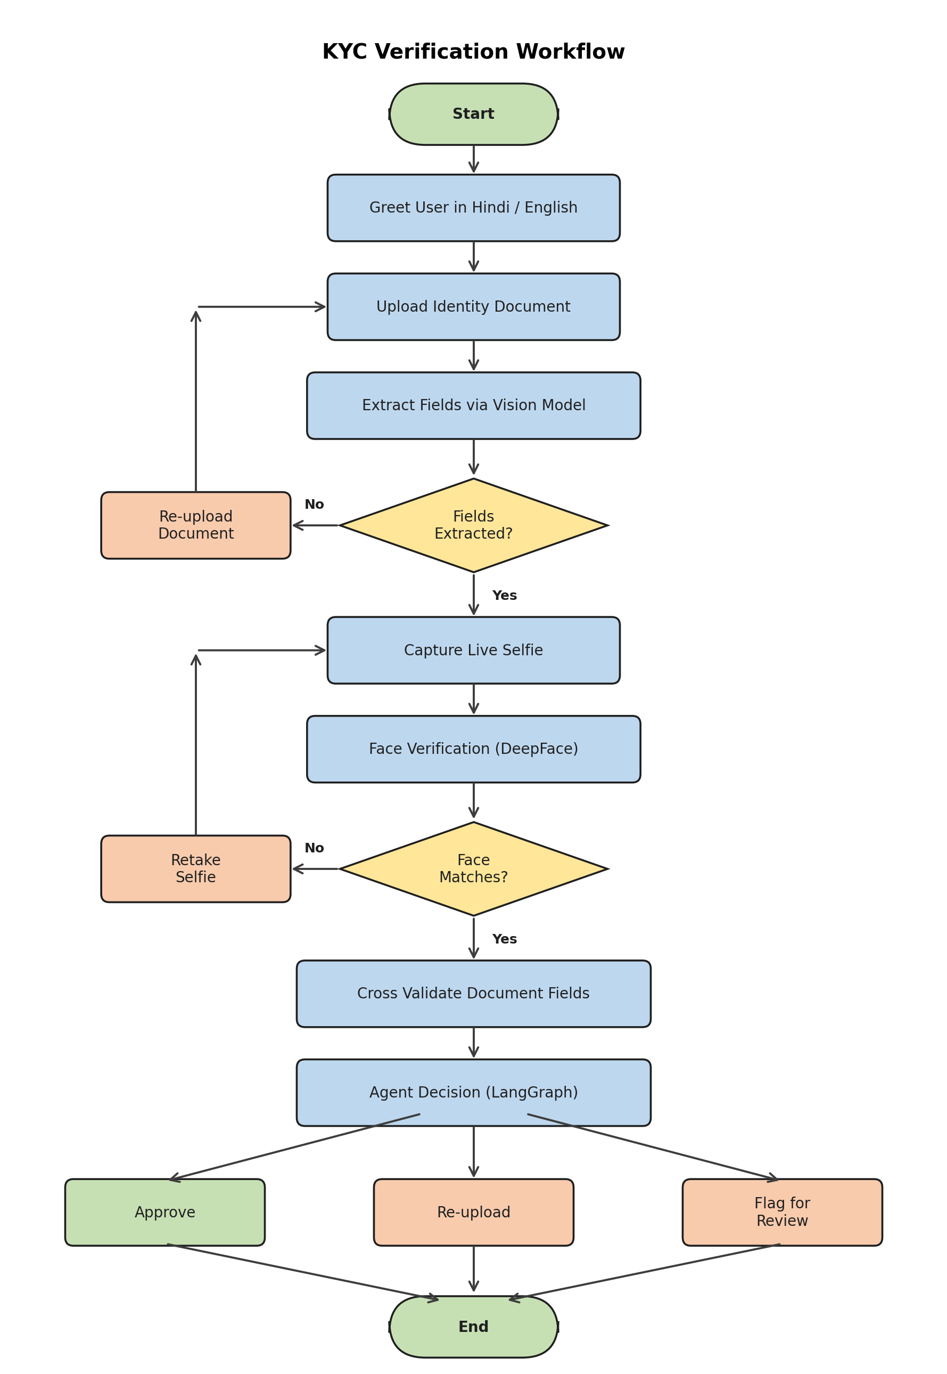
Figure 4.1: KYC Verification Workflow
The vision based document processing gave noticeably better results than classical OCR on the sample documents used during testing. This was particularly true for images with logos, colored backgrounds, or Hindi text mixed in with English. Name and date of birth came out cleanly on clear images. Blurred or cropped inputs did lose accuracy, which was expected. DeepFace produced reliable similarity scores on clear frontal selfies, and the cross document validation logic correctly caught the mismatches in the deliberately inconsistent test inputs. LangGraph and RAG also held up well during testing and made it straightforward to branch the flow in different directions depending on the outcome of each step.
Compared against the existing systems discussed in Chapter 2, the proposed system improves most clearly on the usability side. Traditional paper based KYC is slow and heavily manual. Typical digital KYC systems are faster but tend to ask the user to work their way through a stiff, multi step form with minimal help. The Conversational KYC Assistant sits between these two: the automation of digital KYC, with a guided, chat based layer on top. Bilingual support for Hindi and English also broadens who can actually use the system.
Some parts of the work are still in progress. The admin module for reviewing and managing KYC cases, face liveness detection with MediaPipe Face Mesh, gender and age estimation as an extra cross check, and TTS support for audio responses are all being developed in parallel. The current system is, therefore, best thought of as a working POC that demonstrates the feasibility of an agentic KYC flow. Model accuracy still depends heavily on input quality, so future work around image quality checks, fallback handling, and richer audit logging will help the system hold up in less forgiving real world conditions.
Taken together, the results from the internship show that a stack combining a LangGraph agentic workflow, a RAG knowledge layer, a Python FastAPI backend, and modern vision and face verification models is a practical way to simplify KYC for users who are not already comfortable with digital platforms. The POC is a good base to build on, and the remaining features should slot into it cleanly in the next phase.

Chapter 5: Summary of Work
The goal of this internship was to design and build a Conversational KYC Assistant that makes KYC easier to follow, especially for users who are not yet comfortable with digital platforms. Over the course of the internship, the core modules of the system were built, integrated, and tested as a working Proof of Concept.
On the frontend side, a chat based interface was built in React with shadcn/ui. It covers document upload with preview, a camera view for selfie capture, and a progress indicator that keeps the user informed throughout the KYC flow. On the backend, a set of REST APIs was built in Python with FastAPI. These APIs handle file uploads, run the AI pipelines, and return structured responses back to the frontend.
The AI side includes a vision based document processing pipeline that pulls structured fields out of Aadhaar and PAN card images, a DeepFace based face verification module that scores the user’s selfie against the document photograph, and a set of validation rules that cross check name and date of birth across documents. LangGraph ties the whole flow together, and a RAG pipeline handles grounded answers to KYC questions during the conversation.

Key Accomplishments
- End to end KYC flow that runs from document upload to a final decision without manual intervention.
- Agentic workflow designed and implemented in LangGraph, with each KYC stage modeled as its own node in the graph.
- Vision based document processing pipeline that holds up better than classical OCR on typical Indian ID documents.
- DeepFace integration for face verification, along with the validation logic that turns similarity scores into decisions.
- Bilingual conversational prompts in Hindi and English so the assistant is usable by a wider set of people.
- RAG pipeline integrated into the conversation for grounded answers on compliance related questions.

Deliverables
- React based frontend with chat, document upload, and camera screens built using shadcn/ui.
- Python backend built on FastAPI that exposes REST APIs for the full KYC flow.
- LangGraph based agentic workflow that drives the whole KYC process.
- Integrated AI modules for document processing and DeepFace face verification.
- PostgreSQL schema for user data, uploaded document references, and verification results.
- Technical documentation covering the architecture, API contracts, and the overall flow of the assistant.

Future Recommendations
Based on how the POC came together, there are a few directions that naturally come next. The admin module, face liveness detection with MediaPipe Face Mesh, gender and age estimation, and TTS support are the obvious immediate steps and are already being worked on.
Beyond that, widening support to more document types, adding basic image quality checks to reject poor uploads earlier in the flow, and extending the audit logging in the data layer would take the system much closer to a real deployment. On the conversational side, growing the RAG knowledge base with more up to date compliance material will let the assistant answer a broader range of user questions with confidence.

References
Lewis, P., Perez, E., Piktus, A., Petroni, F., Karpukhin, V., Goyal, N., Küttler, H., Lewis, M., Yih, W., Rocktäschel, T., Riedel, S., & Kiela, D. (2020). Retrieval-Augmented Generation for Knowledge-Intensive NLP Tasks. In Advances in Neural Information Processing Systems (Vol. 33, pp. 9459-9474). https://doi.org/10.48550/arXiv.2005.11401
Lugaresi, C., Tang, J., Nash, H., McClanahan, C., Uboweja, E., Hays, M., Zhang, F., Chang, C. L., Yong, M. G., Lee, J., Chang, W. T., Hua, W., Georg, M., & Grundmann, M. (2019). MediaPipe: A Framework for Building Perception Pipelines. arXiv preprint arXiv:1906.08172. https://doi.org/10.48550/arXiv.1906.08172
Ramírez, S. (2018). FastAPI: Modern, fast (high-performance), web framework for building APIs with Python 3.7+ based on standard Python type hints. https://fastapi.tiangolo.com/
Reserve Bank of India. (2016). Master Direction on Know Your Customer (KYC) Direction, 2016 (Updated as amended). Reserve Bank of India. https://www.rbi.org.in/
Serengil, S. I., & Ozpinar, A. (2020). LightFace: A Hybrid Deep Face Recognition Framework. In 2020 Innovations in Intelligent Systems and Applications Conference (ASYU) (pp. 23-27). IEEE. https://doi.org/10.1109/ASYU50717.2020.9259802
Appendices

Appendix A: Company Details

Appendix B: Mentor Details

Appendix C: Attendance Report

Figure C.1: Attendance Report

Appendix D: Internship Completion Certificate

Figure D.1: Internship Completion Certificate

Appendix E: Plagiarism Report

Acknowledgement
I would like to sincerely thank my supervisor, Dr. Vishakha K. Gaikwad, and my internship coordinator for their guidance, encouragement, and steady support all through the project. Their mentorship helped me connect a lot of concepts from the classroom to what I ended up doing during the internship, and the perspective they offered at different stages of the work has been genuinely valuable.
I am also grateful to Dr. Mukesh D. Patil, Principal of Ramrao Adik Institute of Technology (RAIT), D. Y. Patil Deemed to be University, for the facilities and the academic environment that made this work possible.
My thanks also go to Dr. A. V. Vidhate, Head of the Department of Computer Engineering, for his constant support and motivation throughout the internship period. I would also like to thank my company mentor and the wider product team, who trusted me with meaningful work and made space for me to learn by building real things. Finally, I am thankful to everyone, family, friends, and classmates, who helped me directly or indirectly in completing this project report.

Date:

Swarnima Negi (DY22ENGUOCOM166 − 22CE1117)

